BUSINESS REQUIREMENTS,
Prepared for TechMarket
Friday, January 05, 2024
Version 1.0

Prepared by
………………

Revision History
Date | Version | Author | Change Description
18/11/2023, 03:00 PM | 0.1 | Khai Ngo | Initial creation
20/11/2023, 11:16 PM | 0.2 | Khai Ngo | Define application overview
21/11/2023, 11:23 AM | 0.3 | Khai Ngo | Upload domain model
21/11/2023, 04:10 PM | 0.4 | Khai Ngo | Modify domain model
21/11/2023, 08:47 PM | 0.5 | Duong Dinh | Upload use case diagram
22/11/2023, 09:00 AM | 0.6 | Duong Dinh | Write description for use cases
23/11/2023, 10:41 AM | 0.7 | Duong Dinh | Modify use case diagram
21/12/2023, 1;27 AM | 0.8 | Duong Dinh | Modify use case diagram
05/01/2024, 9:03 PM | 1.0 | Khai Ngo | Modify use case diagram
Approval
Date | Version | Approver Name | Position
20/11/2023 | 0.1 |  | Application Owner
20/11/2023 | 0.1 |  | ITPM
21/11/2023 | 0.2 |  | Application Owner
21/11/2023 | 0.2 |  | ITPM
21/11/2023 | 0.3, 0.4, 0.5 |  | Application Owner
21/11/2023 | 0.3, 0.4, 0.5 |  | Application Owner
22/11/2023 | 0.6 |  | Application Owner
22/11/2023 | 0.6 |  | Application Owner
23/11/2023 | 0.7 |  | Application Owner
23/11/2023 | 0.7 |  | Application Owner
21/12/2023 | 0.8 |  | Application Owner
21/12/2023 | 0.8 |  | Application Owner
05/01/2023 | 1.0 |  | Application Owner
05/01/2023 | 1.0 |  | Application Owner

Table of Contents
1 Objective and Scope 4
2 Business Requirement 4
2.1. Application Overview 4
2.2. Domain Model 5
2.2.1. Diagram 5
2.2.2. Domain Objects Description 5
2.3. Workflow 7
2.4. Use Cases and Actors 7
2.4.1. Diagram 7
2.4.2. Description of Actors 8
2.4.3. Description of Use Cases 8
2.5. Security Matrix 9
2.6. User Story 11
2.7. Change Requirement 12
3 Appendix 13
3.1. Glossary 13
3.2. Open Issues 13

Objective and Scope
This document describes the business requirements for the TechMarket Project. It contains the overall description of the application, the scope of data migration, and any changes need to be performed during migration of the application.
This document along with the prototype demo is used for requirements confirmation, and it is to be signed off by the business. Details of business logic and graphic user interface of the application, which are not mentioned in this document, will be migrated as they are in the application.

Business Requirement

Application Overview
TechMarket is a used electronics classifieds website. It allows users to post complete information about the item they want to sell, then buyers can consider purchasing.
Administrators can manage user accounts. If a user has a low rating and is reported for trading behavior, the Administrator may consider banning this account. Administrators can review and delete posts that violate business regulations and policies.
Sellers can post posts to sell items including basic information about the item. This post must be reviewed by an administrator to ensure that its information is valid and truthful. Once the post is approved, it will be viewed by everyone who visits the website. A collection of posts managed by the seller themselves with different statuses. TechMarket provides a 'payment guarantee' feature for posts so that buyers can create orders and transfer money to TechMarket's account as a form of intermediary holding money, which will be paid to the seller when The transaction is confirmed by the buyer.
TechMarket offers another interesting feature called 'push post', by using this feature, sellers can push their post to the front page so that it is easily seen by buyers, increasing the likelihood of a sale. .
Buyers can search for desired products on the website and make purchases in two ways. Method 1, text and exchange with the seller to agree on the receiving address, payment method, delivery method,... . Method 2, use the ordering feature for posts that apply 'guarantee payment' to ensure your money is kept safe before receiving the goods. Buyers can also report violative posts.
In addition, users can access the help center to see how to use the website's features and can also send feedback to improve the website.
The Customer Care Department can manage the help center page and process user feedback.

Domain Model

Diagram
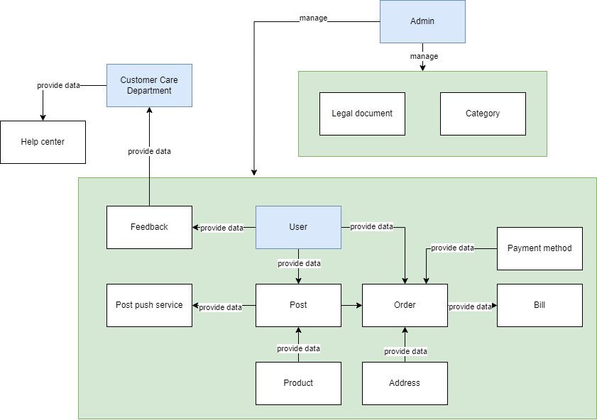

Domain Objects Description
# | Object Name | Object Description
1 | Admin | Users in this group have permission to manage user accounts, posts, legal documents, categories.
2 | User | Users in this group have permission to place order, manage their own posts, leave a feedback
3 | Customer Care Department | Users in this group have permission to view and handle feedback from all users.
4 | Legal document | The object contains the information of legal documents.
5 | Category | The object contains the information of categories
6 | Post | The object contains the post’s information.
7 | Order | The object contains the order’s information, created by the system when the user makes a purchase.
8 | Bill | The object contains the information of the order, buyer, seller and other needed information
9 | Payment Method | The object contains the information of payment method.
10 | Product | The object contains the information of product, just create when user creates a post.
11 | Address | The object contains the information of the shipping address.
12 | Post push service | The object contains the information of the post push service.
13 | Feedback | The object contains the information of feedback
14 | Help center | The object contains the information of help center

Workflow

Use Cases and Actors

Diagram
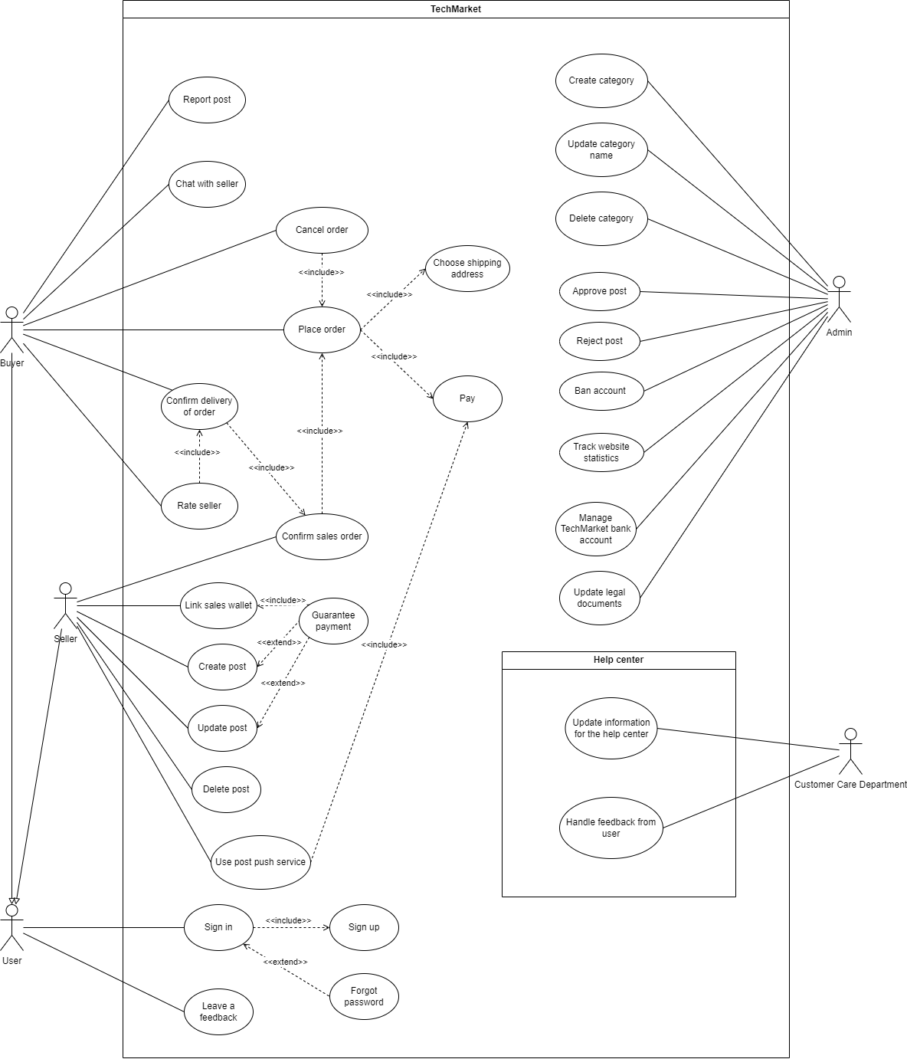

Description of Actors
# | Actor Name | Definition
1 | Admin | Administrator of the whole system, is responsible for order management and post management. Admin makes sure that posts and orders are valid.
2 | User | Who registers with the system
3 | Buyer | Users who want to sell their used electronic device
4 | Seller | Users who want to buy electronic devices
5 | Customer care department | Users who handle customer feedback and provide documents to the help center

Description of Use Cases
# | Use Case Name | Definition
1 | Sign In | This use case describes the process by which a user logs into the system.
2 | Sign Up | This use case describes the process by which a user creates a new account in the system.
3 | Forgot password | This use case describes how user can
4 | Leave a feedback | This use case describes how user can leave a feedback
5 | Create post | This use case descibes how user can create a post for selling electronic devices
6 | Update post | This use case describes how user can update a post
7 | Delete post | This use case describes how user can delete a post
8 | Guarantee payment | This use case describes how users can use guaranteed payment functionality for their posts
9 | Link sales wallet | This use case describes how a user can link to their merchant wallet
10 | Use post push service | This use case describes how a user can use the post push service, increase product sales.
11 | Confirm sales order | This use case describes how sellers can confirm the order of buyers.
12 | Place order | This use case describes how user can place an order for product they want to buy
13 | Choose shipping address | This use case describes how a user can select an existing address or create a new one
14 | Pay | This use case describes how users can pay for their payment
15 | Cancel order | This use case describes how a user can cancel an order
16 | Confirm delivery of order | This use case describes how buyer can confirm that they receive product
17 | Rate seller | This use case describes how buyer can rate the seller after receiving order
18 | Chat with seller | This use case describes how user can contact with seller for finding out more about the product
19 | Report post | This use case describes how users can report violative posts
20 | Create category | This use case describes how users can create new categories for the system
21 | Update category name | This use case describes how a user can change the category information
22 | Delete category | This use case describes how a user can delete a category
23 | Approve post | This use case describes how admin can approve a post to makes it visible on user’s wall
24 | Reject post | This use case describes how admin can reject a post due to the policy
25 | Ban account | This use case describes how a user can ban a user account that violates website’s regulations
26 | Manage TechMarket bank account | This use case describes how a user can manage a client's trading currency storage account
27 | Update legal documents | This use case describes how users can update legal documents related to a publicly available website
28 | Update information for the help center | This use case describes how users can update content and questions for the help center
29 | Handle feedback from user | This use case describes how users can view and respond to customer feedback

Security Matrix
Actor  Function | Admin | User | Buyer | Seller | Customer care department
Sign In |  | x
Sign Up | x | x
Forgot password |  | x
Leave a feedback |  | x
Create post |  |  |  | x
Update post |  |  |  | x
Delete post |  |  |  | x
Guarantee payment |  |  |  | x
Link sales wallet |  |  |  | x
Use post push service |  |  |  | x
Confirm sales order |  |  |  | x
Place order |  |  | x
Choose shipping address |  |  | x
Pay order |  |  | x
Cancel order |  |  | x
Confirm delivery of order |  |  | x
Rate seller |  |  | x
Chat with seller |  |  | x | x
Report post |  |  | x
Create category | x
Update category name | x
Delete category | x
Approve post | x
Reject post | x
Ban account | x
Track website statistic | x
Manage TechMarket bank account | x
Update legal documents | x
Update information for the help center |  |  |  |  | x
Handle feedback from user |  | x |  |  | x

User Story
As a registered user, I want to be able to log in to my account so that I can access personalized features and secure information.
As a new user, I want to be able to create a new account so that I can access the platform's features and services.
As a User who has forgotten their password, I want to be able to reset my password so that I can regain access to my account.
As a Registered user, I want to be able to provide feedback on my experience so that I can share my thoughts and contribute to improving the platform.
As a Registered user I want to be able to create a post to sell a product so that I can list my product for sale on the platform.
As a Registered user I want to be able to update details of my selling post so that I can modify information about the product or adjust the selling terms.
As a Registered user I want to be able to delete a selling post so that I can remove the post from the platform if I no longer want to sell the product.
As a seller I want to be able to guarantee payment so that money will be kept safe and transferred to the seller when the buyer receives the goods as described.
As a seller, I want to be able to link a sales wallet to my account so that I can use it for sales transactions.
As a seller, I want to be able to use the post push service so that my post can be discovered easily by the buyer.
As a seller, I want to be able to confirm the order so that I can recheck the order information.
As a buyer, I want to be able to confirm the order so that I can recheck the order information.
As a buyer, I want to be able to place an order for a product so that I can purchase the desired product and have it delivered.
As a buyer I want to cancel an order so that I can reverse the purchase decision for a specific product.
As a buyer I want to be able to confirm the delivery of a received order so that I can acknowledge the successful receipt of the products.
As a buyer I want to be able to provide a rating for a seller so that I can share my feedback on the seller's performance.
As a user I want to be able to initiate a chat with a seller so that I can communicate directly with the seller for inquiries, clarifications, or negotiations.

As a registered user, I want to be able to report a post created by another user so that I can bring attention to inappropriate content, policy violations, or other issues.
As an Administrator, I want to be able to create a new category so that I can organize products and posts effectively.
As an Administrator, I want to be able to update an existing category so that I can modify category details and keep the system organized.
As an Administrator, I want to be able to delete an existing category so that I can remove unnecessary or outdated categories from the system.
As an Administrator, I want to be able to approve a submitted post so that I can ensure that only valid and appropriate posts are visible on the platform.
As an Administrator, I want to be able to reject a submitted post so that I can ensure that inappropriate or non-compliant posts are not displayed on the platform.
As an Administrator, I want to be able to ban a user account so that I can prevent a user from accessing the platform due to violations or inappropriate behavior.
As an Administrator, I want to be able to update a legal document so that I can ensure that the platform's legal information is accurate and up-to-date.
As a Customer Service Representative, I want to be able to update content in the Help Center so that I can ensure that users have accurate and helpful information to address their queries.
As a Customer Service Representative, I want to be able to manage and respond to user feedback so that I can address user concerns, gather valuable insights, and improve the overall user experience

Change Requirement
# | Item Name | Change Description
1
2
3
4
5
6
7

Appendix

Glossary
Term | Description
BRD | Business Requirements Document

Open Issues

